
MAGNETO CP5-012



Specification of Testbed Requirements
D5.1 Version 1.2
PROJECT CONFIDENTIAL
Author(s) | T. Ergin | Vestel
 | S. Handurukande | Ericsson
 | L. Fallon | Ericsson
 | P. Arozarena | Telefónica I+D
 | R. Toribio | Telefónica I+D
 | A. Carrera | Telefónica I+D
 | J. Montero | Telefónica I+D
 | M. Zach | Siemens
 | J. Kielthy | WIT-TSSG
 | M. García | Blusens
 | A. Estévez | Blusens
 | R. M. Vinuesa | GMV
 | M. G. Mateos | GMV
 | Date: 2026-11-07 | Pages: 35

Executive Summary
D5.1 provides the requirements specification for the test environment that is needed to validate the MAGNETO project. Therefore, the main goal of this document is to describe the necessary equipment (hardware, software, tools, etc.) to build a test-bed for testing the MAGNETO project.
For that purpose, the requirements the testbed must fulfil are collected and then classified according to the categories stated below. Each requirement is assigned a set of fixed fields like description and priority.
- OVN User HAN. This is the HAN of a user that is accessing a MAGNETO service and therefore contains the corresponding client devices.
- OVN User Provider. This is the HAN of the user that provides the OVN service and therefore contains the corresponding server devices.
- MSP Intranet. It simulates the Intranet of the MSP, and it contains both MAGNETO servers and simulated OSSs.
- Connectivity. In order to communicate the domains described above, some means of connectivity are needed that simulate, with some restrictions, a public network.
- Additional Requirements. In this category general requirements, as for example those related to security, are described.
In addition to the basic infrastructure to deploy the MAGNETO prototype, a set of additional tools are described. These tools include multimedia streaming tools, traffic monitoring tools that enable gathering QoS metrics and QoS degradation tools to force service affecting problems.
D5.1 version 1.2 is focusing on the first and second iterations of the MAGNETO prototype and only describes the infrastructure needed to validate these releases. As new releases of the prototype become available, the deliverable will be updated accordingly.
Table of Contents
1. Document Information 5
1.1. Document History 5
1.2. Keywords 5
1.3. Glossary and Abbreviations 5
1.4. Purpose of the Document 6
1.5. Project Internal References 6
1.6. External References 6
1.7. Relationship to Other Documents 6
1.8. Open Issues 7
2. Introduction 8
3. Scenario overview 9
4. Requirements and Components of the MAGNETO Testbed 11
4.1. OVN Provider Network 11
4.1.1. REQ-TESTBED-1: Dedicated Multimedia Server 11
4.1.2. REQ-TESTBED-1-b: VoD server 11
4.1.3. REQ-TESTBED-2: PC as a Multimedia Server 11
4.2. OVN User Network 11
4.2.1. REQ-TESTBED-3: TV and STB as a Multimedia Client 12
4.2.2. REQ-TESTBED-4: PC as a Multimedia Client 12
4.3. MSP Intranet 12
4.3.1. REQ-TESTBED-5: MSP Server 12
4.3.2. REQ-TESTBED-6: MSP OSS Simulator 13
4.4. Connectivity 13
4.4.1. REQ-TESTBED-7: Home Gateway 15
4.4.2. REQ-TESTBED-8: MSP Gateway 15
4.4.3. REQ-TESTBED-9: Connection to the Internet 16
4.4.4. REQ-TESTBED-10: Network Infrastructure 16
4.5. Additional topics 16
4.5.1. REQ-TESTBED-11: Management capabilities of the home devices 16
4.5.2. REQ-TESTBED-12: Management capabilities of the network devices 17
4.5.3. REQ-TESTBED-13: Internet TV content streaming server in the Internet 17
4.5.4. REQ-TESTBED-14: Network Isolation 17
4.5.5. REQ-TESTBED-15: Code Isolation 17
5. Tools 19
5.1. VLC 19
5.1.1. Requirements 19
5.1.2. Configuring the Server 19
5.1.3. Configuring the Client 20
5.1.4. Connecting video streaming protocols with the Web brower 20
5.1.5. Other options to start the streaming VLC client 21
5.2. Traffic Monitoring Tools 21
5.2.1. Active Tools 21
5.2.1.1. Iperf 21
5.2.1.2. Netperf 22
5.2.1.3. Nuttcp 22
5.2.2. Passive Tools 22
5.2.2.1. Wireshark 22
5.2.3. Conclusion 26
5.3. QoS degradation tools 26
5.3.1. Packet loss simulation 27
5.3.2. Traffic Policing 27
Appendix A – Simulation of a Home Gateway on a Linux PC 28
A.1. Hardware requirements 28
A.2. Software requirements 28
A.3. Steps to configure a PC to behave as Home Gateway 28
Appendix B – Vestel MAGNETO4800 Device 31
Appendix C – Blusens' ServerBOX 33

Index of Tables
Table 1: Document History 5
Table 2: Glossary and Abbreviations 6
Table 3: Project Internal References 6
Table 4: External References 6
Table 5: Open Issues 7

Index of Figures
Figure 1: MAGNETO Scenario. 10
Figure 2: MAGNETO Scenario Focused on Connectivity 14

Document Information

Document History
Version | Date | Comments | Editor
Draft 0.1 | 10/14/09 | Initial Draft with complete document structure and inputs fro participants. | TanılErgin,  Vestel
Draft 0.2 | 27/11/09 | Second Draft with updated ToC. | Pablo Arozarena,  Telefónica I+D
Draft 0.3 | 12/12/09 | Added open issues section, modified VESTEL’s requirements with the input of other partners. | TanılErgin,  Vestel
Vers. 1.0 | 23/12/09 | Final updates and Executive Summary added. | Pablo Arozarena,  Telefónica I+D
Vers. 1.1 | 22/03/10 | NAT removed from scenario topology.  Section on passive monitoring tools added. | Pablo Arozarena,  Telefónica I+D
Vers. 1.2 | 06/07/10 | Information on Whireshark included.  Installation on Fedora Linux described. | Pablo Arozarena,  Telefónica I+D
Table 1: Document History

Keywords
MAGNETO, Outer Edge, Network Management, Testbed. Home devices, traffic monitoring, QoS.

Glossary and Abbreviations
Term | Explanation
HAN | Home Area Network
HD | High Definition
IP | Internet Protocol
IPTV | Internet Protocol Television
ISP | Internet Service Provider
MSP | MAGNETO Service Provider
NAT | Network Address Translation
OSS | Operations Support System
OVN | Omnipresent Virtual Network
RTP | Real-time Transport Protocol
RTSP | Real Time Streaming Protocol
QoS | Quality of Service
STB | Set Top Box
VOD | Video on Demand
Table 2: Glossary and Abbreviations

Purpose of the Document
This document explains the requirements, definition, and structure of a testbed that is suitable to test the MAGNETO prototypes. As such it shall guide the creation of a MAGNETO test environment from scratch.
In its V1.2 release, D5.1 focuses on the first and second iterations of the MAGNETO prototype. It will be updated appropriately when new functionality is added to this prototype in future iterations of the project.

Project Internal References
No. | Short Code | Document Reference
1 | D2.1 | MAGNETO Context, Scenarios and Use Cases.
2 | D4.1 | Initial Scenario Architecture Specification
3 | D4.2 | Hardware Platform Specification And Development Support
4 | D4.3 | Component Design Specifications
Table 3: Project Internal References

External References
No. | Short Code | Document Reference
Table 4: External References

Relationship to Other Documents
This document is mainly based on the initial use cases definition in deliverables D4.1 and D4.3. Note that the basis for specifying these use cases is the scenario and scenes identified in D2.1. However, D2.1 scope is narrowed down to the first and second iterations of the MAGNETO prototype.
In addition, deliverable D4.2 deals with specifying the hardware platforms needed for the project. This mainly refers to the home devices that will be used to implement the test bed and which are therefore referenced throughout this document.

Open Issues
Number | Description | Issue Closing Comments
1 | Shall we define generic MAGNETO test bed or a test bed that covers prototypes and demonstrations?
2 | Which partners are hosting the testbeds. | All partners involved in WP5 should host their own testbed, sharing the same configuration.
3 | Section Administrative requirements (like access rights, etc.)  Technical requirements, the ones we have now. They may also be further classified into, for instance, infrastructure reqs., test reqs., application reqs. Etc | Section removed. New classification added.
4 | Overlapping requirements | Overlapping managed.
5 | Dynamic configuration of shapecfg: is it possible? | Postponed to next iteration.
6 | Check support of video streaming in Server Box. | Streaming capabilities have been added to the out-of-the-box functionality. For this, ffmpeg tool will be used.
7 | Check compatibility between Server Box and Vestel’s 4800 STB. | It will be based on RTP/RTSP.
Table 5: Open Issues

Introduction
As a part of the MAGNETO project, prototypes and demonstrations are planned. In order to have a testbed for demonstrations and prototyping, the requirements of testbed that can be used in MAGNETO project must be defined. This deliverable aims to define the requirements of such a testbed.
MAGNETO has in its nature, remote connectivity which means that the testbed requirements that will be defined in this document must not be limited to only one local network.
The main goal of this document is to be able to provide the necessary data to anyone whishing to build up a full featured MAGNETO test environment.

Scenario overview
Figure 1 depicts the necessary MAGNETO testbed scenario in order to validate the first and second iterations of the prototype. It identifies the main required hardware components (note some of them may be simulated) and shows how they will be connected.
In MAGNETO, the sharing of multimedia contents between two home users is addressed. These contents are stored in a video server inside one of the HANs and are remotely accessed from the other HAN. The focus in the first two iterations of the MAGNETO prototype is on VoD streaming between two HANs.
Starting with this basic scenario, two management use cases have been identified in D4.3: fault diagnosis and QoS monitoring.
As it can be seen in Figure 1, four main parts are identified in the testbed:
- OVN Provider network. The HAN providing the multimedia content.
- OVN User Network. The HAN consuming the service.
- MSP Intranet. A LAN belonging to the MAGNETO service provider, and it includes both MSP’s servers hosting the MAGNETO components and any necessary simulated OSSs.
- ISP Network. One or several real ISPs providing Internet access to home users. In our testbed, it is just a switch and 100 MB links connecting the other elements.
Further details to be taken into account when studying this test bed are:
- Each HAN has a home gateway, which is a MAGNETO Enabled Device (i.e. a device with enough resources to run MAGNETO software).
- The MAGNETO server inside the MSP Intranet is also a MAGNETO Enabled Device.
- The OVN User can watch a video stream using different devices (for example, a PC or a TV connected to a STB).
- The OVN Provider can stream video by means of different devices (for example, a dedicated multimedia server or a PC with some video streaming software).
From the points above, we can see that there are different server-client combinations, and all of them should be supported by MAGNETO.
Several use cases will be studied in MAGNETO. These use cases have both specific and common requirements regarding testbed equipment. To achieve a common infrastructure for all use cases, the testbed shown in Figure 1 will be initially used and further extended when new functionalities are incorporated to the MAGNETO prototype.

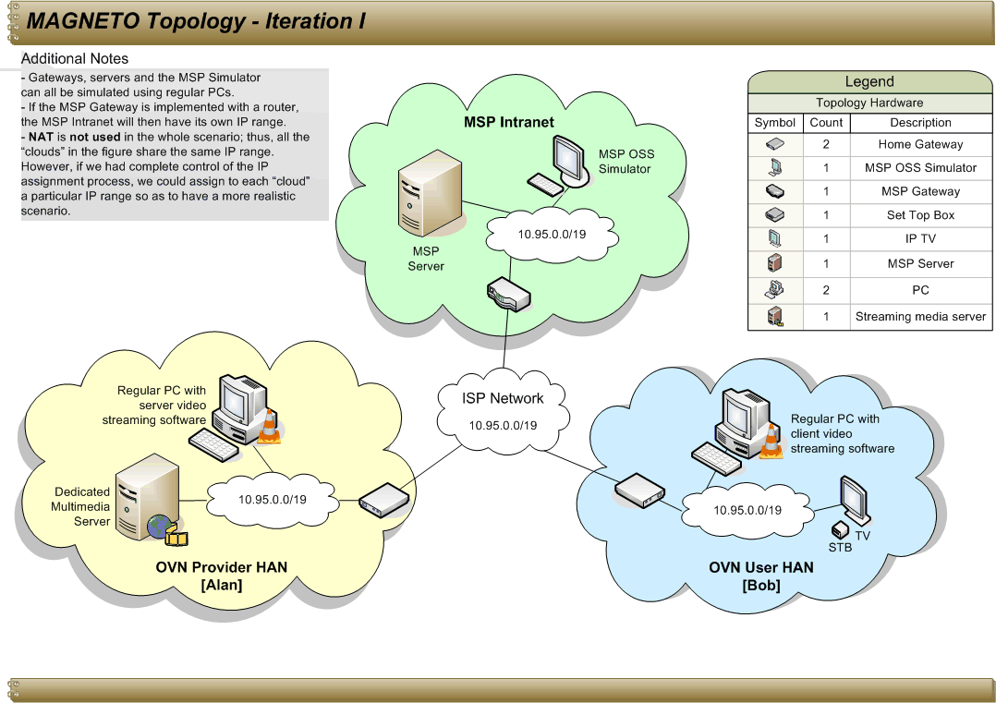
Figure 1: MAGNETO Scenario.

Requirements and Components of the MAGNETO Testbed

OVN Provider Network
This section provides the requirements for deploying the OVN Provider Network depicted above in Figure 1.

REQ-TESTBED-1: Dedicated Multimedia Server
Description: One dedicated multimedia server is required in order to provide media sharing to users. If a dedicated server is not available, REQ-TESTBED-2 must be fulfilled.
Quantity: 1
Priority: Essential
Related Scenarios: All

REQ-TESTBED-1-b: VoD server
Description: This server will be able to serve requested media from start at any time. This is the main difference from REQ-TESTBED-13, where live streams are considered.
Quantity: 1
Priority: Essential
Related Scenarios: All

REQ-TESTBED-2: PC as a Multimedia Server
Description: One multimedia server is required in order to provide video streaming to users. If a dedicated multimedia server is not available, a PC with some server video streaming software must be used instead (an example of this type of software is VLC).
The video streaming software must be able to stream out VoD using RTSP and RTP.
This PC must be located in a user’s HAN and can also be located inside some ISP’s domain.
For information on how to set a server of video streaming using VLC, refer to section 5.1.
Quantity: 1
Priority: Optional
Related Scenarios: All

OVN User Network
This section provides the requirements for deploying the OVN User Network depicted above in Figure 1.

REQ-TESTBED-3: TV and STB as a Multimedia Client
Description: One TV and one STB are required in order to consume the video streaming provided by a multimedia server. If this combination is not available, REQ-TESTBED-4 must be fulfilled.
The STB must be able to request and receive VoD streaming using RTSP and RTP, and it must be located in a user’s HAN.
For information on the available STBs, refer to Appendix B and C.
Quantity: 1
Priority: Essential
Related Scenarios: All

REQ-TESTBED-4: PC as a Multimedia Client
Description: One multimedia client is required in order to consume the video streaming provided by a multimedia server. If a combination of TV and STB is not available, a PC with some client video streaming software must be used instead (an example of this type of software is VLC).
The video streaming software must be able to request and receive VoD streaming using RTSP and RTP, and it must be located in a user’s HAN.
For information on how to set a client of video streaming using VLC, refer to section 5.1.
Quantity: 1
Priority: Optional
Related Scenarios: All

MSP Intranet
This section provides the requirements for deploying the MSP Intranet depicted above in Figure 1.

REQ-TESTBED-5: MSP Server
Description: In order to host a number of MAGNETO components (for example, components implementing features like self-learning or SALMON), an MSP server is required.
This server can be a PC connected to the MSP Gateway or the MSP Gateway itself if it has been replaced with a PC-switch combination (see REQ-TESTBED-8).
For the demo, using a PC is only recommended if the MSP router is actually a router (not a gateway), or if the gateway does not have enough resources to run the required software.
Quantity: 1 or more
Priority: Essential
Related Scenarios: All

REQ-TESTBED-6: MSP OSS Simulator
Description: To get a better understanding of a problem, MAGNETO may need to request information to external OSSs located in some ISP’s domain (for example, we may need to know the status of a DSL line to perform a fault diagnosis). For the demo, a simulator could be used instead, placing it inside the MSP Intranet for simplicity.
Quantity: 1
Priority: Optional
Related Scenarios: All

Connectivity
The MAGNETO scenario depicted above in Figure 1 shows what the MAGNETO scenario is like and how the different devices are distributed and interconnected. However, in order to understand properly how the scenario must be, a new diagram is provided below in Figure 2. This diagram shows, in a more detailed way, the required networking devices and the way they are interconnected.

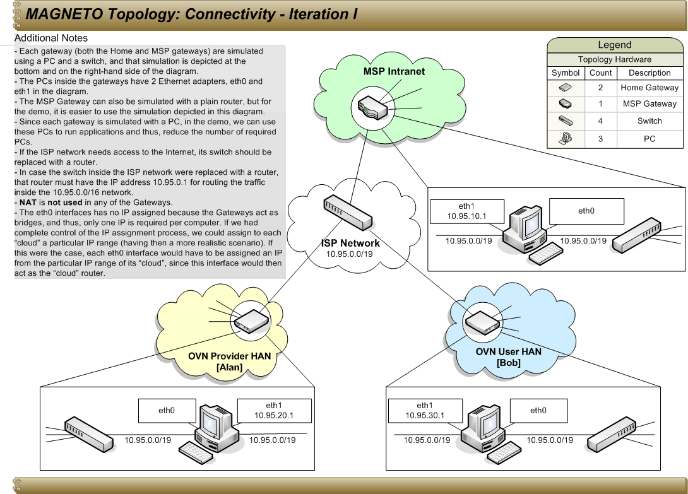
Figure 2: MAGNETO Scenario Focused on Connectivity

REQ-TESTBED-7: Home Gateway
Description: To simulate a HAN, it is required a Home Gateway device capable of acting as a router and executing some MAGNETO software.
For the demo, we have decided to simulate each Home Gateway with a PC equipped with 2 Ethernet adapters and a switch: the PC will act as a powerful bridge and the switch will allow a certain number of devices inside the simulated HAN to connect with the PC.
Notice that having a PC acting as a bridge provides us with enough power to execute applications such as a client video streaming software, reducing so the number of PCs required for the demo.
The hardware required for simulating a Home Gateway is the following:
- 1 PC: Pentium IV, 2.8 GHz, RAM 1GB and hard drive 40GB, 2 10/100Mbps Ethernet LAN Adapters. Screen, keyboard and mouse required for monitoring and configuration issues.
- 1 Switch: a 10/100Mbps (or higher) switch with enough ports to connect the desired devices. A possible switch model is “3Com Gigabit Switch 5”.
- 10/100 Ethernet link.
For information on how to configure a Home Gateway properly, refer to Appendix A.
Quantity: 2
Priority: Essential
Related Scenarios: All

REQ-TESTBED-8: MSP Gateway
Description: In order to connect the MSP Intranet with the ISP network, a gateway is required.
This gateway can be simulated with a router or with a gateway similar to the one used in users’ HANs: a PC which will act as a powerful bridge and a switch which will allow a certain number of devices inside the MSP Intranet to connect with the PC.
For the demo, it would be easier to use the second option, since having a PC acting as a bridge would provide us with enough power to execute applications such as MSP OSS Simulators (reducing so the number of PCs required).
The hardware required for simulating the gateway like a Home Gateway is the following:
- 1 PC: Pentium IV, 2.8 GHz, RAM 1GB and hard drive 40GB, 2 10/100Mbps Ethernet LAN Adapters. Screen, keyboard and mouse required for monitoring and configuration issues.
- 1 Switch: a 10/100Mbps (or higher) switch with enough ports to connect the desired devices. A possible switch model is “3Com Gigabit Switch 5”.
- 10/100 Ethernet link.
If instead, it is decided to use a router, it will be required:
- A 10/100Mbps (or higher) router with enough ports to connect the desired devices.
For information on how to configure properly the gateway simulated with a PC and a switch, refer to Appendix A, where it is explained how to configure a Home Gateway.
Quantity: 1
Priority: Essential
Related Scenarios: All

REQ-TESTBED-9: Connection to the Internet
Description: To simulate parts of Scene 5, The ISP network must have access to the Internet. In this case, the ISP networking device should be a router.
Quantity: 1
Priority: Optional
Related Scenarios: Scene 5

REQ-TESTBED-10: Network Infrastructure
Description: A network to connect all MAGNETO enabled devices is needed. The networking elements required to deploy the scenario depicted in Figure 2 are as follows:
- 2 Home Gateways for the HANs (see REQ-TESTBED-7).
- 1 Switch for the ISP Network: a 10/100Mbps (or higher) switch with enough ports to connect the desired devices (at least 3). A possible switch model is “3Com Gigabit Switch 5”.
- 1 MSP Gateway for the MSP Intranet (see REQ-TESTBED-8).
- 10/100 Ethernet links to connect the networking devices.
Note: The switch in the ISP Network must be replaced with a router if the ISP network needs to have access to the Internet.
Quantity: 1
Priority: Essential
Related Scenarios: All

Additional topics

REQ-TESTBED-11: Management capabilities of the home devices
Description: In order to support all scenes, MAGNETO should be aware of:
- The type of home devices available.
- The management capabilities they provide in terms of different types of events, alarms and status information.
- How to access this management information? It can be via either a management interface or a programming API.
Quantity: not applicable
Priority: Essential
Related Scenarios: All

REQ-TESTBED-12: Management capabilities of the network devices
Description: In order to support all scenes, MAGNETO should be aware of:
- The type of network devices available
- The management capabilities they provide in terms of different types of events, alarms and status information.
- How to access this management information? It can be via either a management interface or a programming API.
Quantity: not applicable
Priority: Optional for first and second iterations

REQ-TESTBED-13: Internet TV content streaming server in the Internet
Description: To simulate parts of the Scene 5 the test-bed will need a TV streaming server in the Internet. This will serve live streams, so user will not be able to choose the beginning nor the content.
Note: this requirement is not addressed in the first two iterations of the MAGNETO prototype.
Quantity: 1
Priority: Optional
Related Scenarios: Scene 5

REQ-TESTBED-14: Network Isolation
Description: As stated in previous Requirements, the devices need Network Connectivity. As they will transmit and receive critical user’s information, it is important to assure that it is only received by the intended recipient. For that reason, the devices must be able to cope with Secure Communications:
- SSL/HTTPS
- Key-exchange for Secure RTSP
Quantity: Not applicable
Priority: Essential
Related Scenarios: All

REQ-TESTBED-15: Code Isolation
Description: MAGNETO Enabled Devices are ready to execute code that can be deployed automatically. This code can be a threat to the device as it could be released by a malicious party to attack the device. Moreover, it is also possible that a piece of code can cause problems to the device’s performance without be intended to. For that reason, the MAGNETO Enabled Devices should be ready to execute code in a Sandbox, configuring the Linux Security Extensions (SELinux).
Quantity: Not Applicable
Priority: Optional
Related Scenarios: All

Tools

VLC

Requirements
In order to configure the scenario, the following elements are necessary:
- VLC 1.0.3 for both the server and the client.
- Ubuntu 9.1 as the OS of the server machine.
- Windows XP as the OS of the client machine. Notice that other OS’s should also work.
- Some MPG files for the server.

Configuring the Server
Bearing in mind that the server has Ubuntu 9.1 and has VLC 1.0.3 installed, the following steps are to be taken:
- Open an instance of VLC, open its telnet interface and specify the host in charge of handling RTSP requests. For this, open a console and type the following command:
vlc --extraintf telnet --rtsp-host 10.95.25.223:5554
where 10.95.25.223 is the ip of the server and 5554 is the port where RTSP requests will be received.
- Connect to the telnet interface of the VLC instance you have just opened. For this, open another console and type the following command:
telnet 10.95.25.223 4212
where 10.95.25.223 is the ip of the server and 4212 is the port that VLC uses for connections to its telnet interface.
- The previous command will ask you for a password, so type admin, which is the default password.
- Now that you are connected to the telnet interface of the VLC instance you opened at the beginning, type the following VLC command line for each video that you would like to stream as VoD:
new video1 vod enabled input /home/a_video.mpg
where video1 is the alias that you assign to the video file with absolute path /home/a_video.mpg.
You can automate this step by using a configuration file. This way, with only one VLC command line, you can stream as many videos as you want. In order to use a configuration file:
  - Create a new empty configuration file named vod.cfg.
  - Type in it all the VLC command lines you need. For example:
new video1 vod enabled input /home/first_video.mpg
new video2 vod enabled input /home/second_video.mpg
new video3 vod enabled input /home/third_video.mpg
  - In the console with the connection with the telnet interface, type the following VLC command line:
load /home/vod.cfg
where /home/vod.cfg is the absolute path of the configuration file you have just created.
- Now, you can close the telnet connection if you want (type exit), but do not close the VLC instance you opened at the beginning.
- When you want to stop providing VoD streaming, just close the VLC instance.
Note
If you want to stop providing a particular video as VoD streaming, you do not need to close VLC. Instead, you can use the following VLC command line (using the VLC telnet interface):
del video1
where video1 is the alias of the particular video you want to stop providing as VoD streaming.

Configuring the Client
Bearing in mind that the client has VLC 1.0.3 installed, the following steps are to be taken:
- Open the VLC application and in the menu, select Media+Open network stream…
- In the field named Address, type:
rtsp://10.95.25.223:5554/video1
where 10.95.25.223 is the ip of the server, 5554 is the port that the server uses to receive RTSP requests, and video1 is the alias of the requested video.
Make sure that the information you provide in the above URL matches the information you set in steps 1 and 4 in the Configuring the Server section.
Click the Play button and wait for the video to start.

Connecting video streaming protocols with the Web brower
For MAGNETO, we can have a web page with all the content that can be streamed out. If we use, for instance, rtsp as the Session Protocol to enable video streaming, there must be a way to open the video streaming application that can handle that type of protocol. In order to achieve this, we must register the new rtsp protocol in the Operating System, so that it is associated with an application (such as VLC media player).
The procedure changes depending on the Operating System. This is explained in http://kb.mozillazine.org/Register_protocol. In particular, for Windows, we can create a file called RegisterRTSP.reg with the following contents:
REGEDIT4
[HKEY_CLASSES_ROOT\rtsp]
@="URL:rtsp Protocol"
"URL Protocol"=""
[HKEY_CLASSES_ROOT\rtsp\shell]
[HKEY_CLASSES_ROOT\rtsp\shell\open]
[HKEY_CLASSES_ROOT\rtsp\shell\open\command]
@="\"C:\\Archivos de programa\\VideoLAN\\VLC\\vlc.exe\" \"%1\""
Then, after executing this file, a new register is added into the Registry.

Other options to start the streaming VLC client
From a Web based GUI, the direct connection between rtsp URL and start of VLC as described above might be the best option. If, for any reason, this is not possible, streaming can be initiated by starting VLC from the command line. In our example the following command has to be typed:
vlc [options] rtsp://10.95.25.223:5554/video1
where options could include any scenario specific way how the video should be displayed (size, volume, display of extra information, verbosity level, etc.)
Note that from a MAGNETO perspective two ways of issuing this startup command are possible in principle:
- from a shell script that takes a few dynamic parameters (like server address, video file),
- from the VLC device adapter which is receiving the necessary input parameters (note that this option would have to be considered during component design).

Traffic Monitoring Tools
In this section we describe a number of bandwidth and traffic monitoring tools that are useful in Magneto project. Depending on how a tool carries out a measurement, that tool can be categorized as active (intrusive) or passive (non-intrusive) tool. There are many active and passive tools that can be useful to check performance and traffic analysis of a network link. We describe a number of them briefly.

Active Tools
The active tools are intrusive and for measurements these tools introduce their own traffic to the network. They can be used to measure bandwidth, jitter, delay and packet loss of a given network link. Particularly these tools are very useful to measure the upper limits and capabilities of a network link; these tools can impose heavy load in terms of packet transmission and measure performance in heavily loaded situations.
In the following section we describe Iperf, Netperf and Nuttcp; these are active monitoring tools that can be used in MAGNETO.

Iperf
Iperf can be used to evaluate:
- bandwidth,
- latency
- jitter and
- packet (datagram) loss
This intrusive (or active) tool uses client-server mode where 2 entities run in 2 different computers. These 2 entities exchange packets between them to measure above mentioned traffic properties between the 2 computers.
Though this tool can measure the network link properties of the link between the computers it is running, it cannot measure the exact network performance of a particular session, for example of an IPTV session, that is running between 2 computers or any other two multimedia devices.

Netperf
This tool can be used to evaluate
- Unidirectional bandwidth,
- Latency (request/response time)
Like Iperf it is an intrusive (or active) tool. It also uses control “channel” to exchange data between client and server.

Nuttcp
Nuttcp is similar to iperf and netperf. It has 2 components and is an active measurement tool. It provides bandwidth, packet loss (UDP) etc.

Passive Tools
Passive measuring tools do not introduce their own traffic but monitor the network/device passively by observing the packets that are going through a particular network interface or through a network link. Such tools are useful to find details about a particular session for example of a given IPTV session. More specifically details such as packet loss, jitter and delay of a given IPTV session can be measured using these tools.
In the following section we describe a powerful passive monitoring tool that can be used in Magneto project.

Wireshark
Wireshark is a tool that can be used both in Linux and Windows environments to capture packets and related details of the network performance. In relevant to the Magneto project, Wireshark can be used to find out details such as:
1) RTP Packet loss
2) Total number of RTP packets
3) Maximum jitter (for RTP)
4) Mean jitter (for RTP)
5) Maximum Delta between packets
6) Sequence errors in the stream
8) Average bandwidth (MBit/sec)
The way these RTP performance parameters are calculated and their precise definitions are described in http://wiki.wireshark.org/RTP_statistics.
Additionally, Wireshark can be used to plot graphs over time showing the temporal behaviour of a traffic flow. Wireshark can produce results according the filters that users can specify. For example users can specify only to capture the packets of a given IPTV session (based on IPs for example).
Wireshark can monitor traffic that is going through the interface it is monitoring (Ethernet or wireless interface). However, it is not trivial to monitor all the traffic going through an Ethernet switch since a switch isolates Ethernet collisions domains (hence traffic isolation). But there are various methods to capture such traffic.
Installing Wireshark
Wireshark can be installed in Linux and Windows based computers.
Wireshark can be downloaded using the following link:
http://www.wireshark.org/download.html
As stated in user’s guide of the Wireshark it can be used on widely used versions of Windows (XP, Vista etc.) and different variants of Linux (Debian, Red Hat, Ubuntu etc.).
You would need following minimum requirements:
- Any modern 32-bit x86 or 64-bit AMD64/x86-64 processor.
- 128MB available RAM. Larger capture files require more RAM.
- 75MB available disk space.
- Ethernet card: Any card supported by Windows should work.
- OR 802.11 WiFi
- Disk space for capturing files (e.g., around 200MB)
(Ref:- http://www.wireshark.org/docs/wsug_html_chunked/ChIntroPlatforms.html)
In Windows environment, each Windows installation package comes with a library called WinPcap. During the installation process when you are given the option to install this library you should install this library as well.
Once the Wireshark is downloaded and installed it can be used to capture packets.
Capturing Packets
Wireshark can be used in different settings to capture packets. In Magneto we use RTSP to deliver IPTV content. In this section Wireshark usage is explained using an example where IPTV content is delivered from ServerBox to a VLC client over RTSP. Given that we use RTSP/RTP in our project (i.e., RTSP initialling the IPTV delivery session), description given in this section strictly assumes delivery over RTSP (i.e., no other protocols).
As stated earlier, for ease of explanation and understanding, Wireshark usage is explained based on an example. Once the basic concepts and usage of Wireshark are familiar, one can use it in other more complex settings.
Following diagram shows the example capturing setup.

RTSP
ServerBox
Computer with VLC & Wireshark Installed
Network/LAN
Ethernet Interface
Figure 3: Wireshark Example

In the above example we consider ServerBox streaming RTSP to a VLC client that is installed in a computer. Wireshark is also installed in this computer (if we consider STB as the client, we would have to consider a capturing setup where Wireshark is installed in the emulated Home Gateway). As a first step it makes sense to use VLC client on a computer and having Wireshark in the same computer. The Network/LAN in the above figure can consist of other network devices (e.g., emulated HG running Iptables to drop packets).
To capture files launch the installed Wireshark tool. The following figure shows first screen. The interfaces that can be used for sniffing are listed as shown in the following figure. Depending on your hardware setup and network driver/interface details, there could be different interfaces listed. Click the appropriate interface to start capturing. Then start a IPTV stream from VLC client. It is important to note this sequence: Wireshark should be started and capturing packets before the IPTV stream is started. When traffic is flowing you would see packets. You can stop/start packet capturing using the buttons located at the top left corner. After a period of time (example 1minute) one can stop capturing packets.
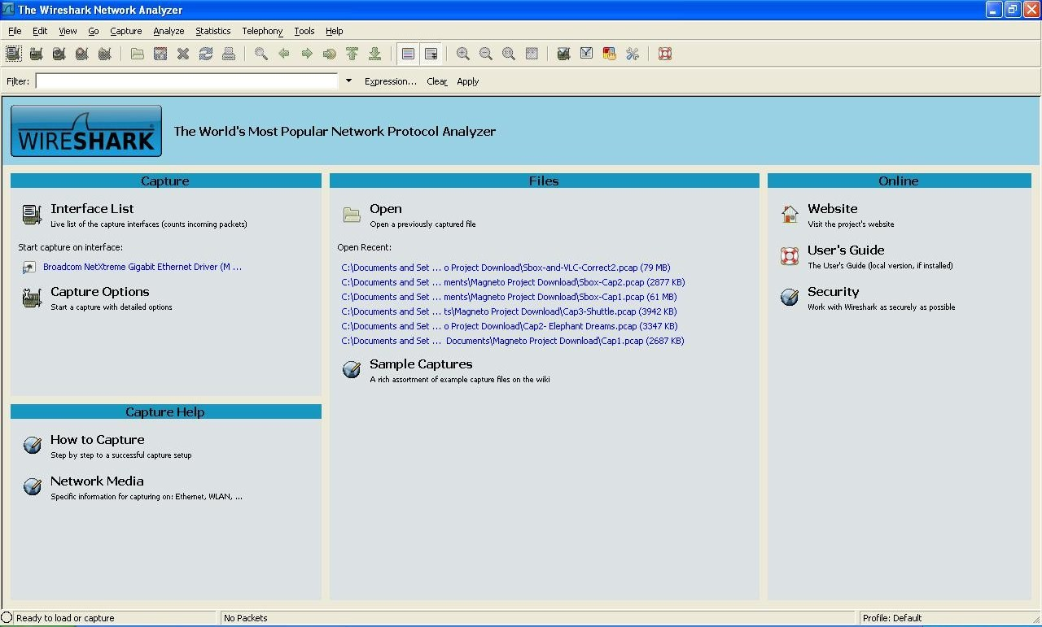
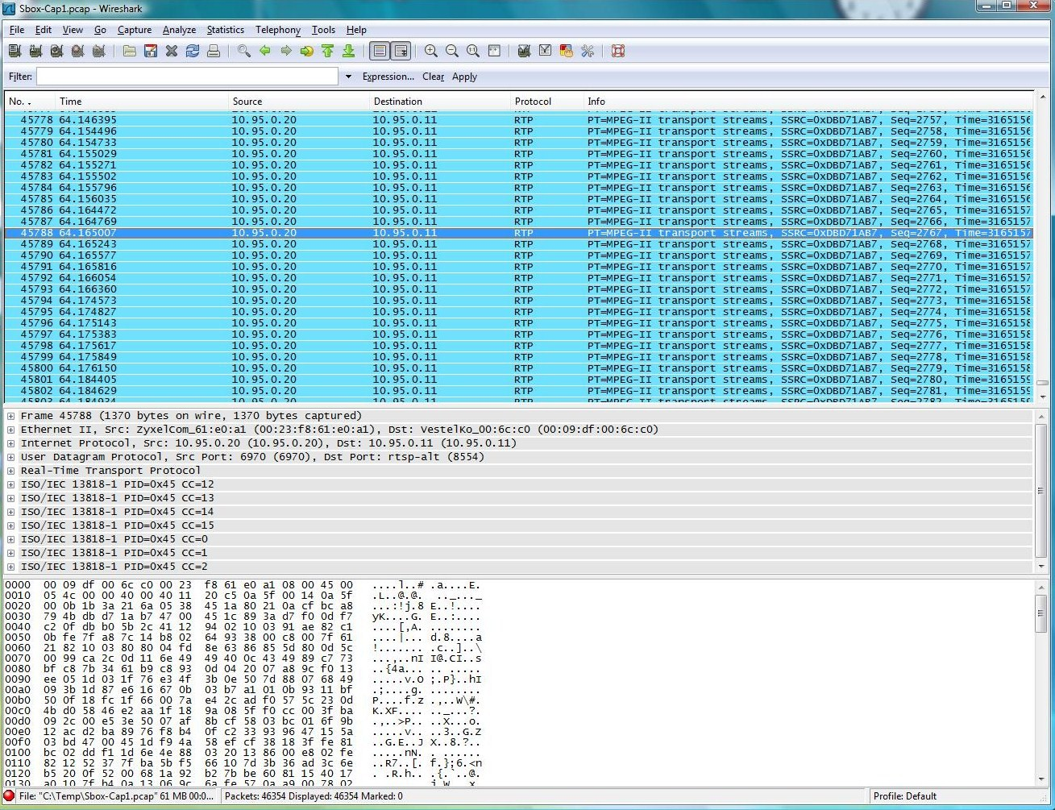
The above figure shows captured packets. You can use the Stop button located at the top left corner. Once the packet capturing is stopped the captured file can be saved using the File menu.
Once a given RTP packet is highlighted (RTP is shown in the Protocol column as shown in the above figure), information related to that packet is shown on the screen.
To get the details of the RTP stream (which was initiated by the RTSP), use the following menu options while a particular RTP packet is highlighted:
- Telephony → RTP → Stream Analysis.
Then you would get details on the screen; an example is shown below. You would see details related to packet loss, jitter, delta, sequence errors etc. for that particular stream.
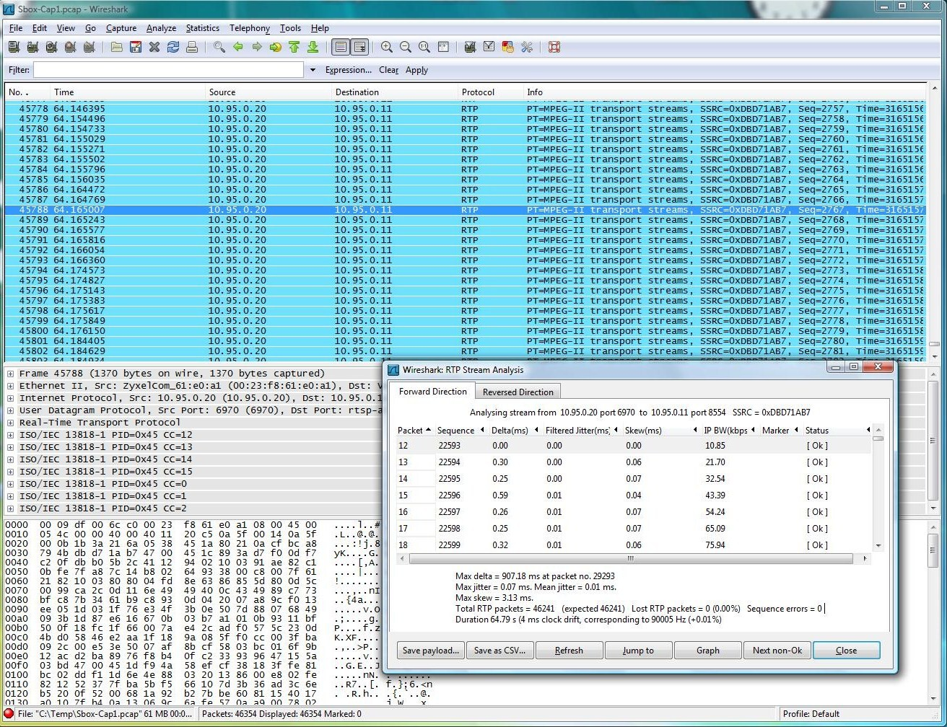
Wireshark installation comes with a command line tool tshark that can be also used.
Further details regarding Wireshark and Tshark can be found in
- http://www.wireshark.org/.

Conclusion
Tools like iperf, netperf and nuttcp can measure bandwidth, latency and packet loss etc. using active measurement methods by introducing its own traffic; these tools generally can inject many packets in a rapid sequence congesting the network. Hence they can be used to measure properties of a network in an extreme case but cannot be used to measure a performance of a given service session like of a given IPTV session. Passive tools like Wireshark can measure properties of a given session like of an IPTV session.

QoS degradation tools
As explained in document D3.2, QoS is one of the challenges related to service assurance. In our testbed we need to simulated scenarios where quality is not good in order to check the correct functionality of our devices and the behaviour of the system as a whole, following the worst case design rules. As a result of these tests we will be able to apply the necessary changes in order to make the system works well.
Since we are dealing with a system where connectivity is the key feature, we have to simulated situations where it would be diminished. In order to reach this goal two different approaches can be taken (or both):
- Packet loss. Due to network load, usually network devices can not queue all the packets that they receive before sending them to destination. These packets are discarded. So, in this point, this situation will be simulated
- Traffic shaping. Theoretically, traffic rate at reception will be the same than in the sender all the time. But, in practise, it is not true due network latencies, routing policies, etc. So, usually, traffic is received by bursts. In order to simulated this, we have to shape our own traffic.

Packet loss simulation
To simulate QoS degradation, we can use packet loss dropping packages inside a simulated Home Gateway. Using the same library IPTABLES that we use to implement the forwarding feature inside our simulated Home Gateway (see Appendix A); we can drop packets randomly by adding a simple rule. For example, if we want to discard 50% of packets that have as destination 10.95.13.133, we should add the following rule:
iptables -t mangle -A POSTROUTING -d 10.95.13.133 -m statistic --mode random --probability 0.5 -j DROP
Or, if we want to discard 20% of packets that come from subnetwork192.21.0.0/24:
iptables -t mangle -A PREROUTING -s 192.21.0.0/24 -m statistic --mode random --probability 0.2 -j DROP
Moreover, there is another option that allows discarding one packet for every fixed number of packets received. For example, if we want to discard one packet every 50 packets that come from 10.95.25.223:
iptables -t mangle -A POSTROUTING -s 10.95.25.223 -m statistic --mode nth --every 50 -j DROP
These rules can be executed while the Home Gateway is started, making this way experimenting an easier task.
NOTE: This package (with necessary extensions and plugins) is already installed in Ubuntu 9.1 Karmic Koala. If older Ubuntu versions are used, the kernel must be recompiled with extra packages and proper options.

Traffic Policing
There is a number of traffic policing tools that can control IP traffic flow. The shapecfg tool is one of them.
The shapecfg tool can be used in Linux systems to police IP traffic. This utility needs Linux Kernel support. It controls the out going traffic from a network interface (e.g., eth0) but cannot help much to control the incoming traffic. The outgoing traffic is controlled by:
- Creating a virtual interface.
- Attaching the virtual interface to a physical network device
- Specifying the bandwidth for the virtual interface.

Appendix A – Simulation of a Home Gateway on a Linux PC
In this appendix, a possible solution to have a powerful gateway where we can deploy, run, update, etc. our MAGNETO software is presented. This solution is based on the simulation of a Home Gateway on top of a Linux PC running a software router. Two Linux distributions have been tested: Ubuntu and Fedora.

Hardware requirements
To build this Gateway, the following devices are needed:
- 1 computer with two Ethernet adapters
  - External or Internet interface
  - Internal or LAN interface
- 1 switch or 1 hub
- Ethernets link
The computer/home-gateway/router/bridge, in which this configuration has been tested, has the following hardware:
- CPU: Pentium IV (2.8Ghz)
- RAM: 1GB
- Hard disk: 40GB

Software requirements
The following Linux distributions have been successfully tested:
- Ubuntu 9.1 Karmic Koala
- Fedora 12 Constantine.

Steps to configure a PC to behave as Home Gateway
Step 1: Installing OS and packages
Ubuntu
Install Ubuntu 9.1 Karmic Koala on the computer with 2 Ethernet cards. When you install O.S., you install the Linux kernel that has very useful packages to configure a router/firewall/gateway.
To install, the needed package bridge-utils only have to execute the following command:
sudo apt-get install bridge-utils
Fedora
Install Fedora 12 Constantine on the computer with 2 Ethernet cards. When you install O.S., you install the Linux kernel that has very useful packages to configure a router/firewall/gateway.
To install, the needed package bridge-utils only have to execute the following command:
su –
(insert root password)
yum update
(wait for the update)
yum install bridge-utils
Step 2: Configuring the ROUTER/BRIDGE feature
To configure this feature of our gateway, we should use a Linux kernel package named iptables and other named brctl. To get more information, go to:
http://unixhelp.ed.ac.uk/CGI/man-cgi?iptables+8
http://www.linux-tutorial.info/modules.php?name=Howto&pagename=BRIDGE-STP-HOWTO/set-up-the-bridge.html
Here is the script that configures our computer as a gateway (without firewall and without NAT).
SCRIPT TO CONFIGURE THE DEVICE
# iptables binary
IPTABLES=/sbin/iptables
BRCTL=/usr/sbin/brctl
IFCONFIG=/sbin/ifconfig
DHCLIENT=/sbin/dhclient
##########################################
### Load several required packages
modprobe ip_conntrack_irc
modprobe ip_conntrack_ftp
modprobe ip_nat_irc
modprobe ip_nat_ftp
##########################################
### Clean iptables configuration
$IPTABLES -F
$IPTABLES -X
$IPTABLES -Z
$IPTABLES -t nat -F
$IPTABLES -t nat -X
##########################################
### Set policies of router and nat
$IPTABLES -P INPUT ACCEPT
$IPTABLES -P OUTPUT ACCEPT
$IPTABLES -P FORWARD ACCEPT
$IPTABLES -t nat -P PREROUTING ACCEPT
$IPTABLES -t nat -P POSTROUTING ACCEPT
##########################################
# Allow forward packages
echo 1 > /proc/sys/net/ipv4/ip_forward
# Configure the bridge
$IFCONFIG gw0 down
$BRCTL delbr gw0
$BRCTL addbr gw0
$BRCTL addif gw0 eth0
$BRCTL addif gw0 eth1
$DHCLIENT gw0
END OF SCRIPT
Step 3: Running the script at the start of the system
Ubuntu
Configure our gateway to run the script at the start of the system.
Execute the following commands:
chmod +x <your_script>
sudo cp <your_script> /etc/init.d
sudo update-rc.d <your_script> defaults
Fedora
The script needs to be inserted at the end of the file “/etc/rc.d/rc.firewall-iptables”. Before pasting it, comment the existing iptables lines on the file “/etc/rc.d/rc.firewall-iptables” (these lines usually starts with “$IPTABLES ...”).
Step 4: Installing the OSGi platform
Install OSGi platform on the gateway.
There are several implementation of OSGi specification, but we can use, for example, Felix Apache (http://felix.apache.org). To do so, we can install any packages in this computer like in any other Linux distribution.
Now, to use Felix, we should install a Java Runtime Environment (for example, jre6); and, after this, we should run Felix (a simple jar file).
http://apache.rediris.es/felix/felix-framework-2.0.1.zip
Step 5: Connecting the simulated gateway to a LAN
Connect the SWITCH/HUB to the LAN interface to obtain local connection to the client/server machines.

Appendix B – Vestel MAGNETO4800 Device

General features:
Reception | IP
Services | IPTV  VOD  nPVR

Protocols:
Internet/Transport Layer | IGMPv3, TCP, UDP
Application Layer - VOD | RTSP, RTCP, RTP
Application Layer - Internet | HTTP1.1, FTP/TFTP, DHCP/Fixed IP
Network Security & Remote Management | Telnet, SSH, TR-069/TR-135, NTP  SSL2.0/3.0, TLS, DTCP

Inputs & Outputs:
Video | 1 x TV SCART (RS232)  1XVCR Scart ( optional)  HDMI 1.2a with HDCP1.1
Audio | L/R RCA (optional)  S/PDIF (IEC958/61937) digital audio, Optical (optional)
USB 2.0 | x2
RJ45 | 10/100Mbps Base-T Ethernet
RJ11 | (option) Smartport
DC Input | 12V DC, 2A Adapter

Video:
Video Formats | PAL (25Hz Frame Rate)
Decoding | MPEG-4 H.264/AVC HP@L 4(HD), MP@L4(HD), MP@L3(SD)  MPEG-2 MP@HL(HD), MP@ML(SD)  MPEG4 Part2-SD, DivX 3.x, 4.x, 5.x, Xvid (No GMC-Qpel support)  DivX Subtitles
Resolution | 576p, 720p, 1080i
Aspect Ratio | 16:9, 4:3, letter box, pan & scan

Audio:
Audio Formats | Mpeg1 L1/2/3 (MP3)  AAC  DD, DD+  WMA (optional)
Sampling Frequency | 32/44.1/48 KHz

Picture:
Picture Formats | JPEG (.jgp, jpeg, .jpe), BMP, GIF
Max Resolution | Baseline:8000x8000 Progressive 1000x1000
Zoom | N/A
Max Filesize | ~15MB

HW:
Main IC | MPEG Decoder ST7101/ST7109
Flash Memory | 256MB NAND + 8MB NOR
RAM | 128MB system memory+64MB video memory
E2prom | none

Software features:
- Linux Operating System
- C/C++ toolchains
- Web browser
- SW Upgrade via ethernet

Appendix C – Blusens' ServerBOX

The ServerBOX is a NAS with slightly more computational capability.
NAS-related features:
- Marvell 5182 @ 500MHz
- 2 x Serial ATA 2.0 3Gbps
- Ethernet
- WiFi
- USB host
- RAID
- DDNS
- DLNA
- NFS server
- Samba server
- FTP server
Additional Features:
- Telnet and SSH access
- Email alarms: temperature, intrusion detection...
- web server
- P2P client
- Zeroconf

General features:

Services | DLNA/UPnP server  Streaming server  iTunes server  Web/FTP server  Web HTTPS/FTPS server  SSL certificates management  Torrent client  Client/server RSS  Memeo Backup  IP filtering

Protocols:

Internet/Transport Layer | TCP, UDP
Application Layer - VOD | RTSP, RTCP, RTP
Application Layer - Internet | HTTP1.1, FTP/TFTP, DHCP/Fixed IP
Network Security & Remote Management | Telnet, SSH, SSL2.0/3.0, TLS, DTCP

Inputs & Outputs:

USB 2.0 | x2
RJ45 | 10/100/1000Mbps Base-T Ethernet
Power | External Power Adapter 40W, Input: AC100~240V, Output: DC 19V 2.1A  Certificate: CE  POWER Consumption: 40W

Video:

Video Formats | Mpeg1  mpeg2  mpeg4  wmv  flv
Decoding | N/A
Resolution | sqcif, qcif, cif, 4cif, qqvga,  qvga, vga, svga, xga, uxga, qxga, sxga, qsxga, hsxga, wvga, wxga, wsxga, wuxga, woxga, wqsxga, wquxga, whsxga, whuxga, cga, ega, hd480, hd720, hd1080
Aspect Ratio | -

Audio:
Audio Formats | ac3  adpcm  pcm  wma  vorbis  fla
Sampling Frequency | It depends on the selected audio codec.  Usually higher than 22050 or 11025

Picture:
Picture Formats | Jpeg, gif, bmp
Max Resolution | -
Zoom | N/A
Max Filesize | -

HW:
Main IC | Marvell 88F5182
Flash Memory | Intel J3D Nor Flash 4M and Samsung 128M Nand Flash
RAM | DDRISDRAM *2 , Total 128MB
E2prom | None

Streaming capabilities have been added to the out-of-the-box functionality of the ServerBox by installing the live555 tool. This way the ServerBox will be able to stream out in RTP/RTSP, both stored files and live streams (simulated). How this works is explained in deliverable D4.2.

IPTABLES: http://dev.medozas.de/files/xtables/iptables.html

